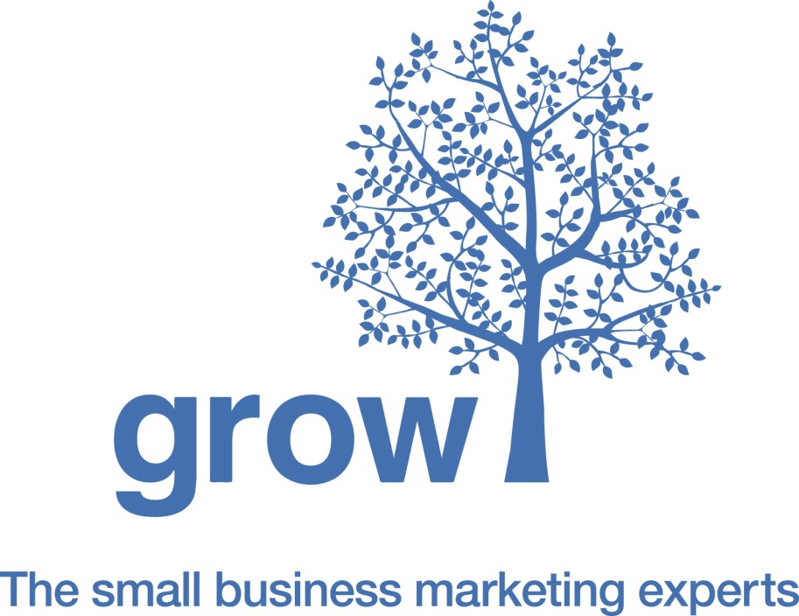
In-Depth Marketing Audit

Business Vision, Strategy and Goals
1. | What is your ultimate long-term business goal?  - Bring in business partners?  - Exit and sell the business?  - Franchise?  - Get investment and scale?  - Leave as a going concern?  - Lifestyle business?  - Lifetime business that provides lifetime income?  - Nationwide awareness and sales?  - Organic and steady growth long term?
2. | What are your business goals in the next 12 months?  These goals can be financial and non-financial goals
3. | What’s the story of your business?  Where did you start from?  How did you get to where you are today?
4. | Please say whether you are strong, average or weak in each of the following business areas:  - Administration  - Business strategy  - Financial management  - Ideas and research  - Managing staff  - Marketing  - Operations  - Recruiting staff  - Sales  - Software systems

Marketing and Sales
1. | What are the 3 key marketing challenges facing your business?
2. | Describe the main products or services that you sell?
3. | What 3 characteristics about your company or service help you stand out from your key competitors?
4. | What marketing methods do you use to generate new business enquiries?
5. | What marketing methods have you tried that have been unsuccessful?
6. | What 3 key problems do you solve for your customers?  Please complete the following sentence  From my customer’s point of view, the 3 key problems that I solve for them are……
7. | Describe your ideal customer for the 3 main products or services you sell?
Business Administration and Operations
Please tell us anything else that you feel will help us understand your business.

Please tell us anything you think it is important that we know…

